FIN 5515 Group Project Write Up: Part One: AI-Powered Investment Screener
- Stock Selection & Screening Criteria
We ended up selecting 10 top tech companies for our stocks:
NVIDIA, INTEL, GOOGLE, AMAZON, META, MICROSOFT, ORACLE, APPLE, TESLA, and AT&T
tickers = ['NVDA', 'INTC', 'GOOGL', 'AMZN', 'META', 'MSFT', 'ORCL', 'AAPL', 'TSLA', 'T']
We chose these for the popularity of tech, its growth potential and its data availability.
Our four Screening criteria were:
- Net Profit Margin > 10% - filters firms that effectively convert revenue to profit / Highly profitable companies
- Dividend Yield > 0.2% - prioritizes companies returning capital to shareholders / ensures companies return cash to investors
- EPS Growth > 8% - growing earnings for long term stock growth / eliminates stagnant companies
- Market Cap > $10B - filters for large, stable and established companies
These balance growth and profitability. Technology-only growth screens can reward unprofitable firms; combining them with margin and income filters helps isolate companies with durable competitive advantages. Five stocks passed all four filters: MSFT, ORCL, GOOGL, AAPL, and META. The remaining five (NVDA, INTC, AMZN, TSLA, T) were excluded primarily for failing the dividend yield or EPS growth thresholds.

- Stock Selection & Screening Criteria
We retrieved the data with the Python finance library. For each ticker we got the profitMargins, dividendYield, earningsQuarterlyGrowth, and marketCap. Rows with missing or non-positive values were dropped in the key screening fields before scoring.

- Composite Scoring & Rankings
We then normalized each metric to [0, 1] using MinMaxScaler and combined these into a weighted composite score:
Composite Score = 0.30 × EPS_score + 0.25 × Margin_score + 0.25 × Dividend_score + 0.20 × MarketCap_score
EPS growth receives the highest weight (30%) as the primary driver of long-term value creation. Net margin and dividend yield are weighted equally (25% each) as indicators of current profitability and income. Market cap (20%) serves as a stability proxy.

4. GPT Investment Summaries
Chat GPT-4 summaries were generated for each top pick by passing each stock's key metrics as a structured prompt to the API. For example: Alphabet Inc. (GOOGL) represents a solid investment opportunity with a high net profit margin of 32.8%. The company, currently with a massive market cap of approximately $3.7 trillion, has shown strong growth with a 29.8% increase in EPS. However, it offers a relatively low dividend yield at 0.28%, and a composite score of 0.40, indicating a balanced risk-reward scenario for potential investors.

5. Visualizations & Takeaways
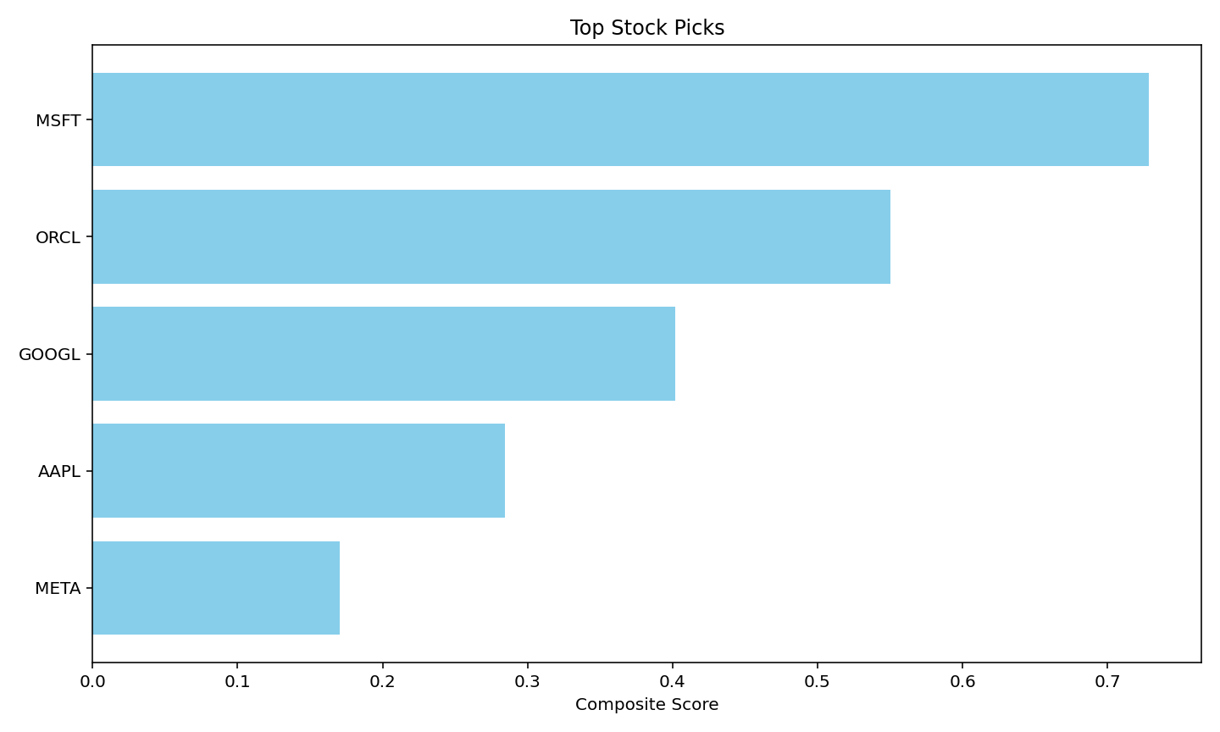

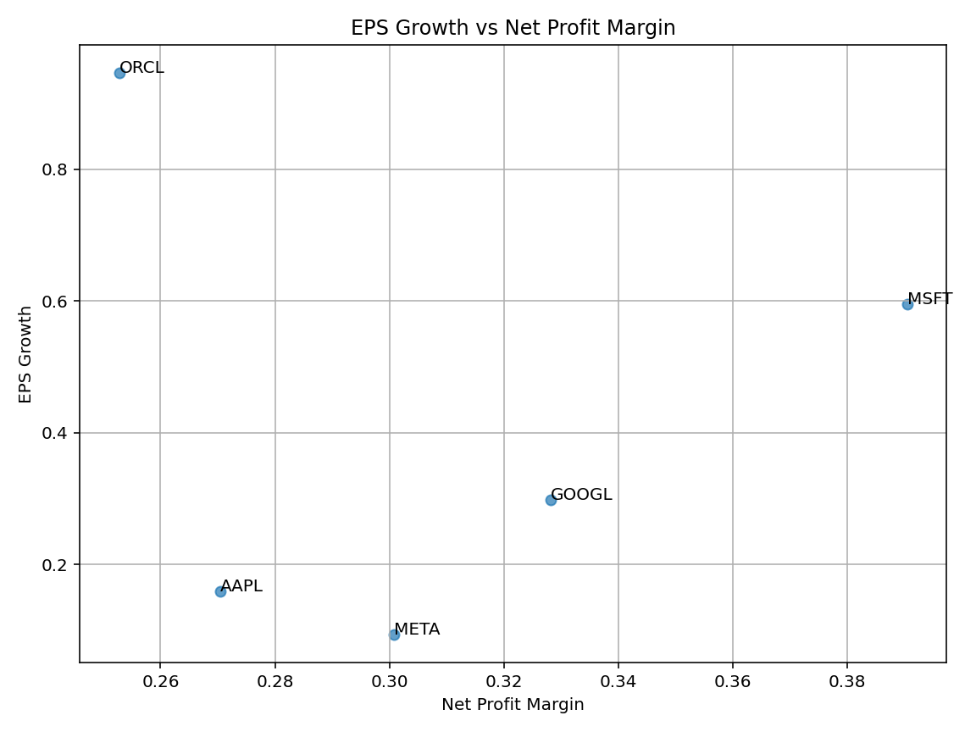
This confirms that high margins alone are insufficient in our model and EPS growth is the decisive differentiator in our composite model. Overall, MSFT and ORCL represent the most compelling opportunities under our framework, so these seem like the stronger ones to invest in. As for Google, Meta, and Apple, these are also strong as they were able to get past our screening criteria, but they aren’t the strongest picks in this selection due to their mediocre composite scores.
MSFT ranked first by a wide margin (0.73) due to its combination of the highest net margin (39%) and strong EPS growth (59.5%). ORCL placed second (0.55) driven by exceptional EPS growth of 94.7%, the highest in the group, though its lower market cap capped the score. GOOGL ranked third (0.40) despite having the second-largest market cap; its near-zero dividend yield (0.28%) limited its dividend score. AAPL placed fourth (0.28) due to modest EPS growth of 15.9%. META ranked last (0.17) with the slowest EPS growth (9.3%) and a minimal dividend.

